1. [Episode 7: Azure Regions and Availability Zones](https://marczak.io/az-900/" \l "ep07)

## **Data Center**

* **Physical facility**
* **Hosting for** a group of networked **servers**
* Own **power**, **cooling** & **networking** infrastructure.

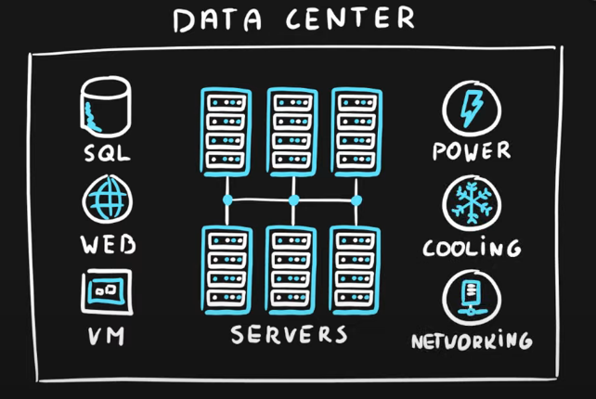

## **Region**

* **Geographical area** on the planet
* **One but usually more data centers** connected with a **low-latency network** (<2 milliseconds)
* **Location** for your services
* Some services are **available only in certain regions.**
* **Regions contain Data Centers.**

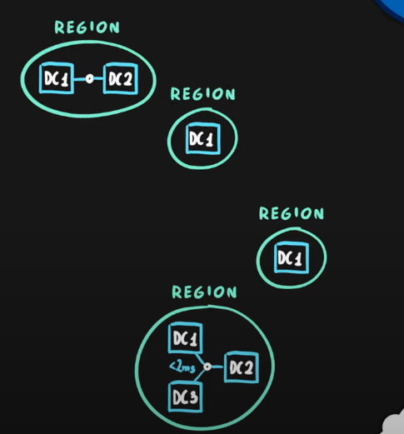

* Some services are **global services**, as such are not assigned/deployed in a specific region.
* Globally available with **50+ regions.**
* Special **government regions** (US DoD Central, US Gov Virginia, etc.)
* Special **partnered regions** (China East, China North)

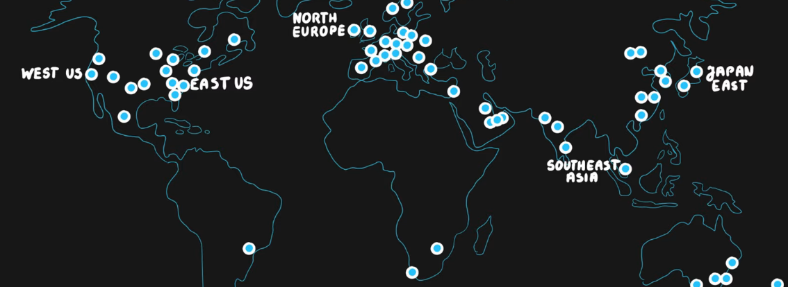

## **Availability Zone**

* **Regional feature, but *not enabled* for *all* Azure Regions.**
* Grouping of **physically separate** facilities.
* Designed to **protect from data center failures.**
* If the zone goes down **others continue working.**
* Two service **categories-**
  + **Zonal** services (Virtual Machines, Disks, etc.)
  + **Zone-redundant** services (SQL, Storage, etc.)
* **Not** **all** regions are **supported. (about 7 supported)**
* **Supported** region has ***three or more zones*.**
* A **zone** is **one or more data centers, meaning, Availability Zones are contained in Regions.**

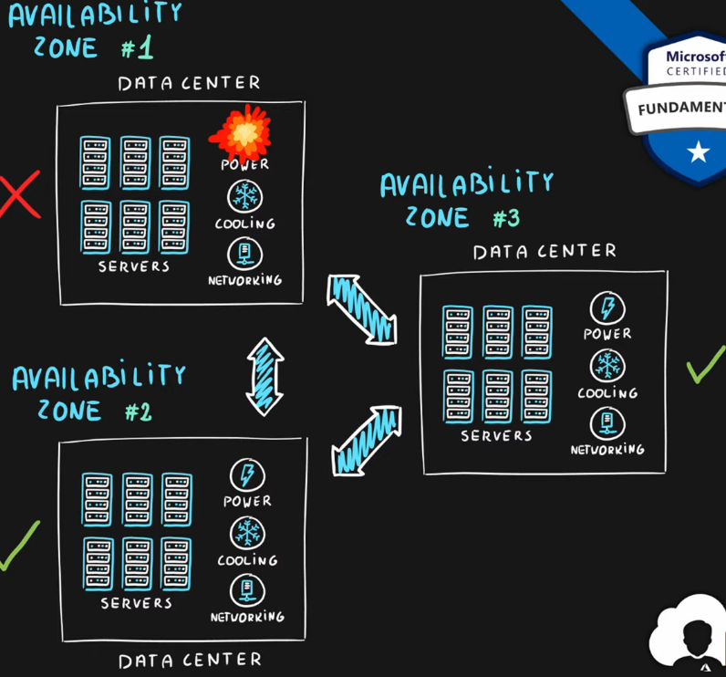

## **Region Pair**

* ***Each* region** is **paired** with another region making it a region pair.
* Region **pairs are static** and cannot be chosen.
* Each pair resides within the **same geography**\*
  + Exception is Brazil South
* **Physical isolation** with at least ***>=300 miles*** distance (when possible).
* Some services have **platform-provided replication.**
* **Planned updates** across the pairs.
* **Data residency** maintained for disaster recovery.

|  |  |
| --- | --- |
| Region Pair A | Region Pair B |
| East US | West US |
| UK West | UK South |
| North Europe (Ireland) | West Europe (Netherlands) |
| East Asia (Hong Kong) | Southeast Asia (Singapore) |

## 

## **Geographies**

* **Discrete market**
* Typically **contains two or more regions.**
* Ensures **data residency**, **sovereignty**, **resiliency**, and **compliance** requirements are met.
* **Fault tolerant** to protect from region wide failures.
* Broken up into areas:
  + **Americas**,
  + **Europe**,
  + **Asia Pacific**,
  + **Middle** **East** and **Africa**
* Each **region belongs only to one Geography.**

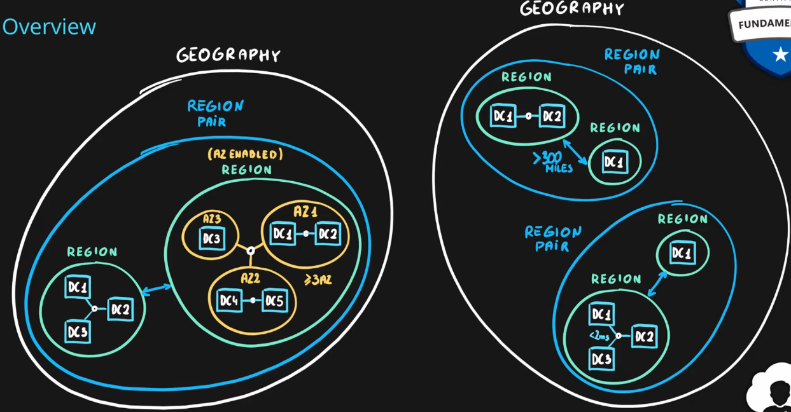

1. [Episode 8: Azure Resource Groups and Resource Manager](https://marczak.io/az-900/#ep08)

## **Azure Resource**

* Object **used to manage services** in Azure.
* Represents **service lifecycle.**
* Saved as **JSON definition.**

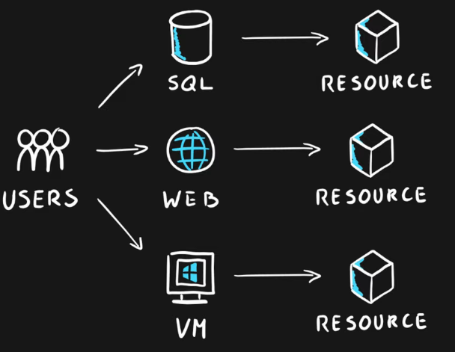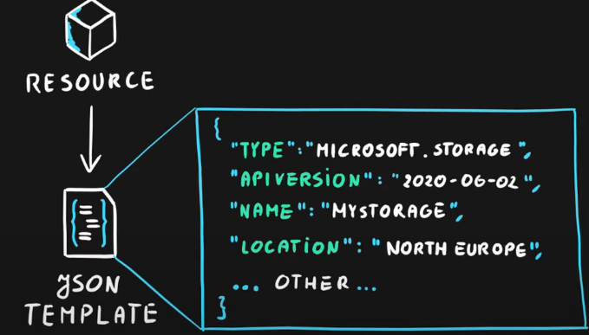

## **Resource Groups**

* **Grouping** of resources with the SAME lifecycle.
* **1 Resource exists in 1 Resource Group** only.
* Holds **logically related** resources.
* Typically organizing by:

|  |  |
| --- | --- |
| * Type * Lifecycle (app, environment) * Department * Billing, * Location or * combination of those |  |

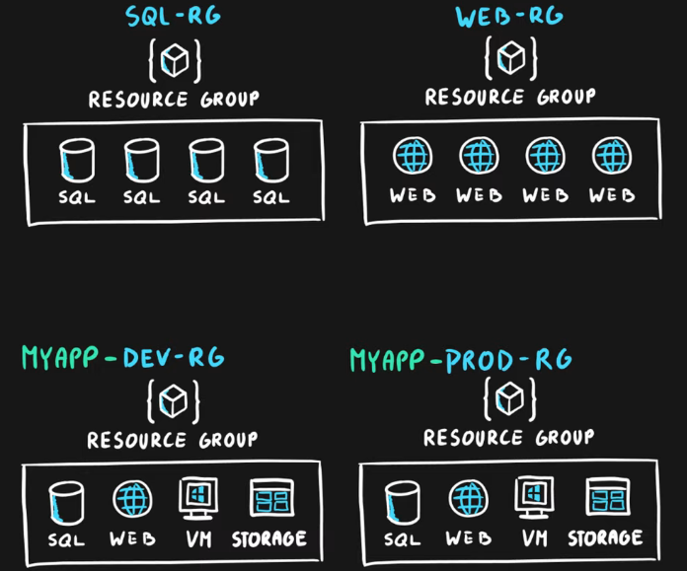

## **Resource Manager**

* **It is a Management Layer** for managing all resources and resource groups.
* **It provides a management layer that enables you to create, update, and delete resources in your Azure account. You use management features, like access control, locks, and tags, to secure and organize your resources after deployment.**
* **Unified** language.
* **Controls** **access** and **resources.**
* **Uses JSON for formatting.**
* **View JSON of Resources:- https://resources.azure.com/**

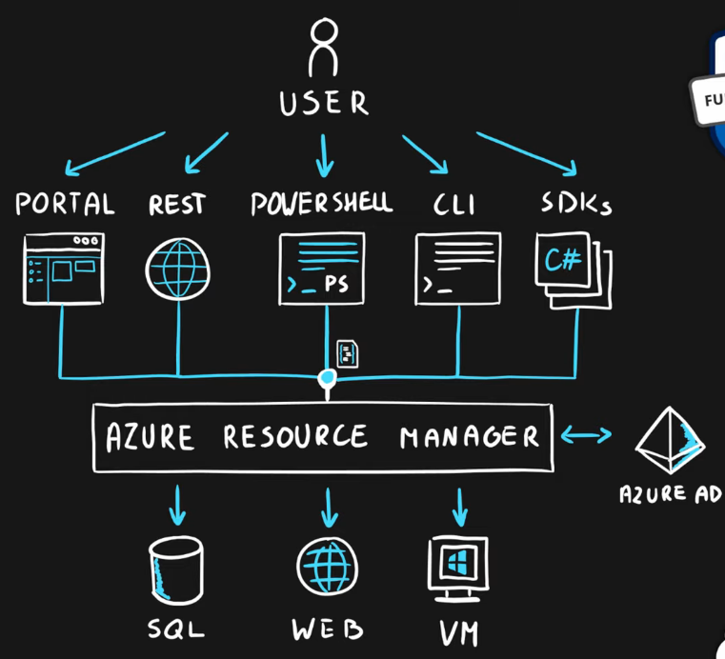

### Additional Info

* Each **resource must** be in one, and **only one resource group.**
* Resource **groups have their own location** assigned.
* Resources in the resource groups **can reside in a different locations.**
* Resources **can be moved** between the resource groups.
* Resource **groups can’t be nested.**
* Organize based on your organization’s needs but consider-
  + Billing
  + Security and access management
  + Application Lifecycle

1. [Episode 9: Azure Compute Services | Virtual Machine, VM Scale Set, App Service, Functions, Container Instances, Kubernetes Service](https://marczak.io/az-900/#ep09)

### Virtualization

* Emulation of physical machines
* **Different virtual hardware configurations per machine/app**
* Different operating systems per machine/app
* Total separation of environments
  + file systems,
  + services,
  + ports,
  + middleware,
  + configuration

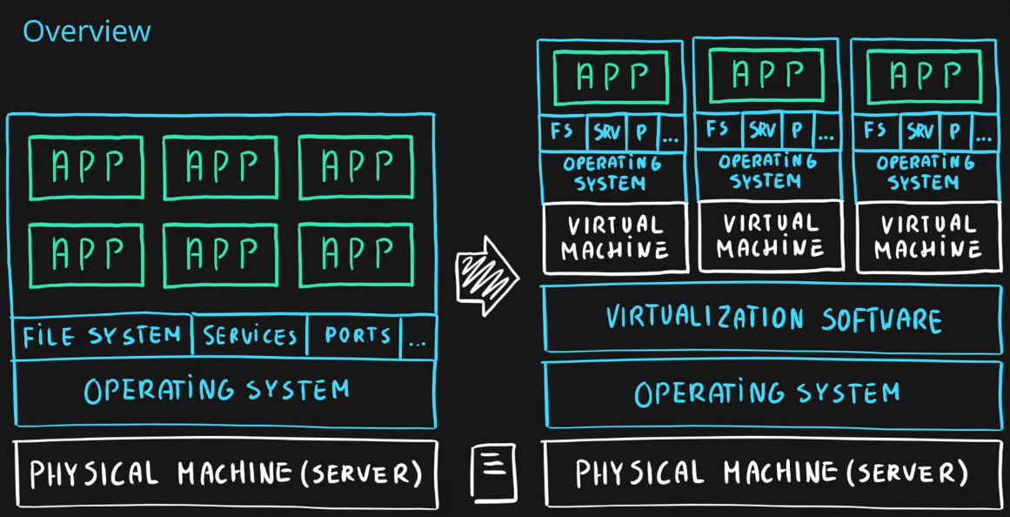

## **Virtual Machines**

* Infrastructure as a Service (IaaS)
* Total **control over the operating system and the software**.
* Supports marketplace and custom images with **only Vertical Scaling**.
* *Used when apps can’t be containerized*.
* Best suited for
  + **Custom software requiring custom system configuration**.
  + **Lift-and-shift** scenarios.
* Can run any application/scenario:-
  + web apps & web services,
  + databases,
  + desktop applications,
  + jump boxes,
  + gateways, etc.

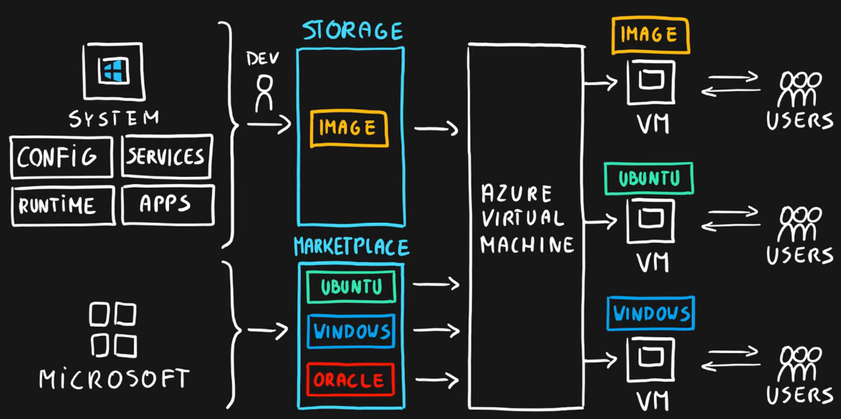

## **Virtual Machine Scale Sets – To scale VM(s)**

* Infrastructure as a Service (IaaS)
* **Set of *identical* virtual machines**
* Built-in ***auto-scaling*** features
* Designed for **manual** and **auto-scaled** workloads like web services,* batch processing, etc.
* Can be **static**(Below example) or **Auto-Scaled**.

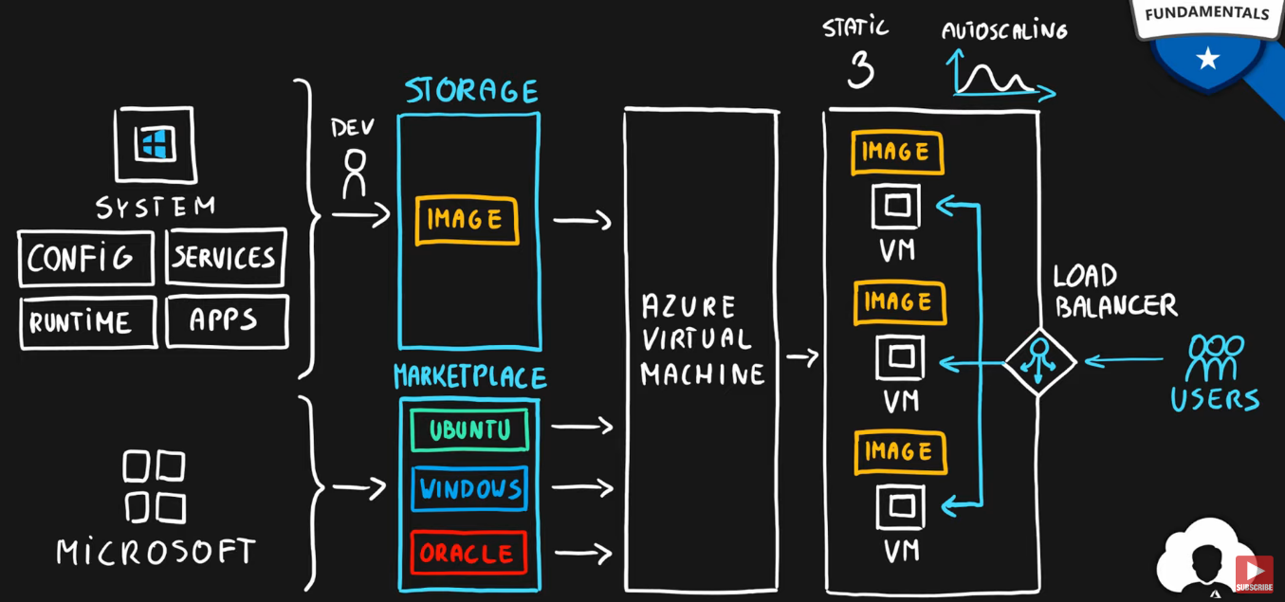

### Containers

* **Container**:- **Sandbox** environment for each app.

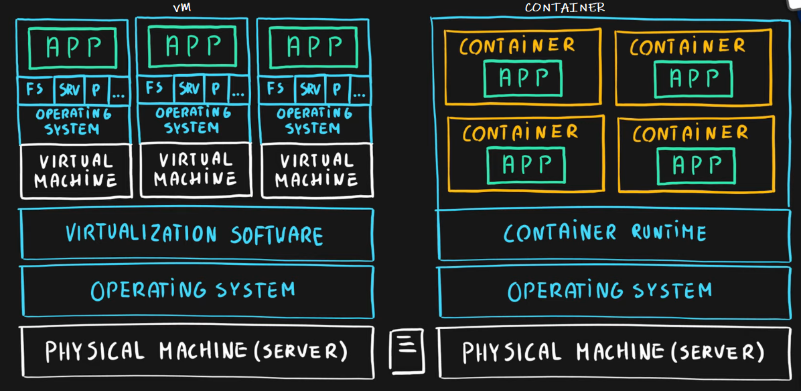

* **Use the host’s operating system** as **they don’t have their own OS**.
* Emulate operating system (VMs emulate hardware)
* Lightweight (no OS)
  + Less Development Effort then VM(s).
  + Less Maintenance than VM(s).
  + Less computing & storage requirements **because no OS**.
* Respond quicker to demand changes.
* Designed for almost any scenario.

## **Azure Container Instances**

* **Simplest** and **fastest** way to run a container in Azure.
* Platform as a Service.(PaaS)
* ***Serverless*** Containers.
* Designed for-
  + **Small** and **simple web apps/services**
  + **Background** jobs
  + **Scheduled** **scripts**.

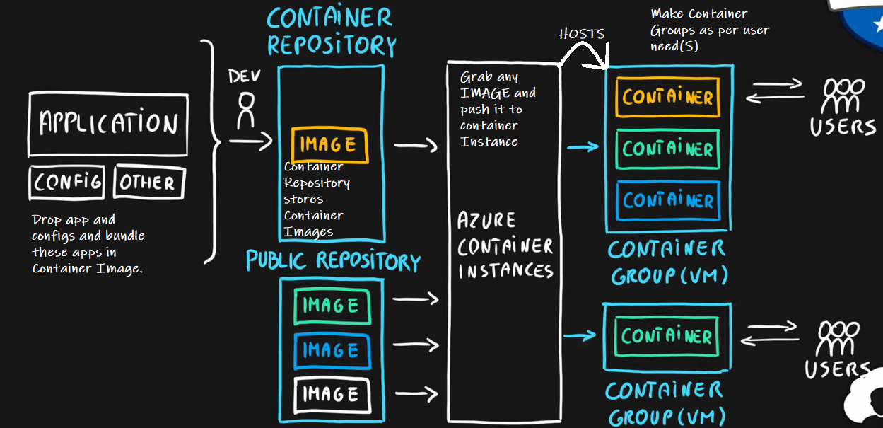

## **Azure Kubernetes Service (AKS)**

* **Open-source** container orchestration platform (PaaS)
* Platform as a Service
* Highly **scalable** and **customizable**
* Designed for **high-scale container deployments** (anything really!)

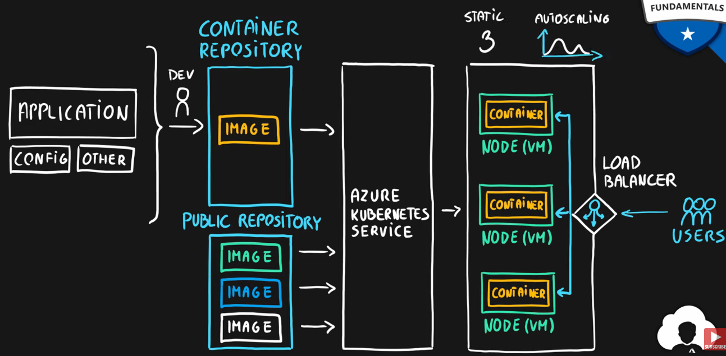

## **App Service for WebApps**

* Designed as ***enterprise-grade web application*** service.
* Platform as a Service. (PaaS)
* Supports multiple programming languages and containers.

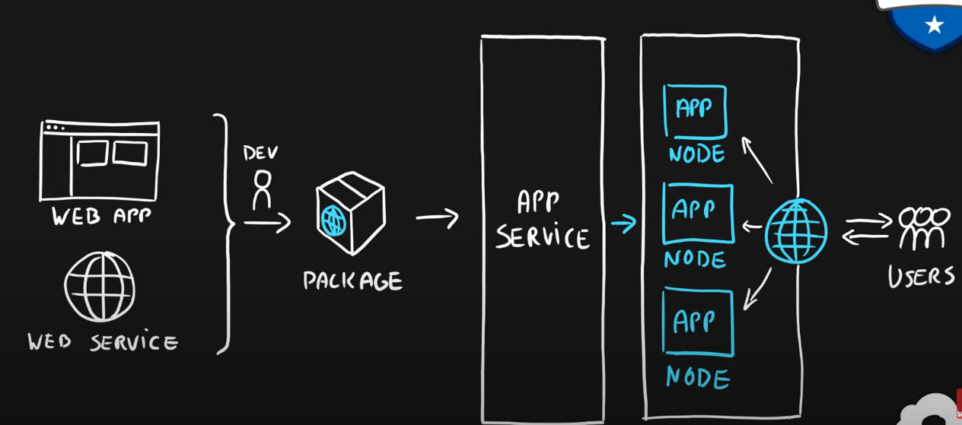

## **Azure Functions (Function Apps)**

* Platform as a Service based on Azure App Functions (PaaS)
* Serverless
* Two hosting/pricing models
  + Consumption-based plan
  + Dedicated plan
* Designed for ***micro/nano-services***, container-based pricing so, it **can be used where the demand of total users is not known like Social Media Apps.**

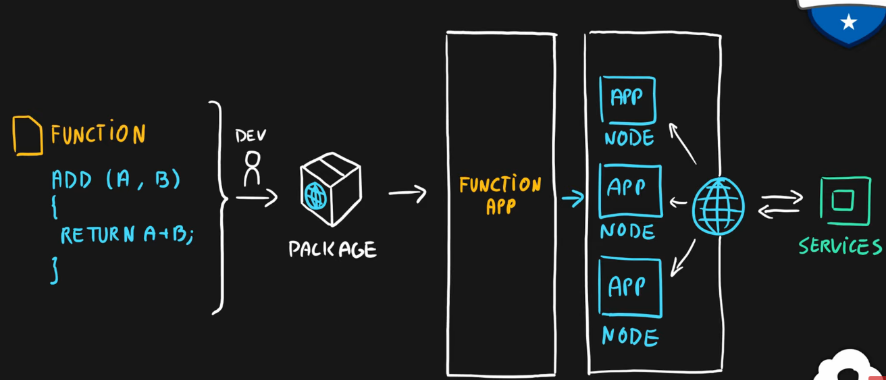

# **Summary**

* ***Virtual Machines (IaaS)*** - Custom software, custom requirements, very specialized, high degree of control.
* ***VM Scale Sets (IaaS)*** - Auto-scaled workloads for VMs.
* ***Container Instances (PaaS)*** - Simple container hosting, easy to start.
* ***Kubernetes Service (PaaS)*** - Highly scalable and customizable * container hosting platform.
* ***App Services (PaaS)*** - Web applications, a lot of enterprise web * hosting features, easy to start.
* ***Functions (PaaS) (Function as a Service) (Serverless)*** - micro/nano-services, excellent consumption-based pricing, easy to start.

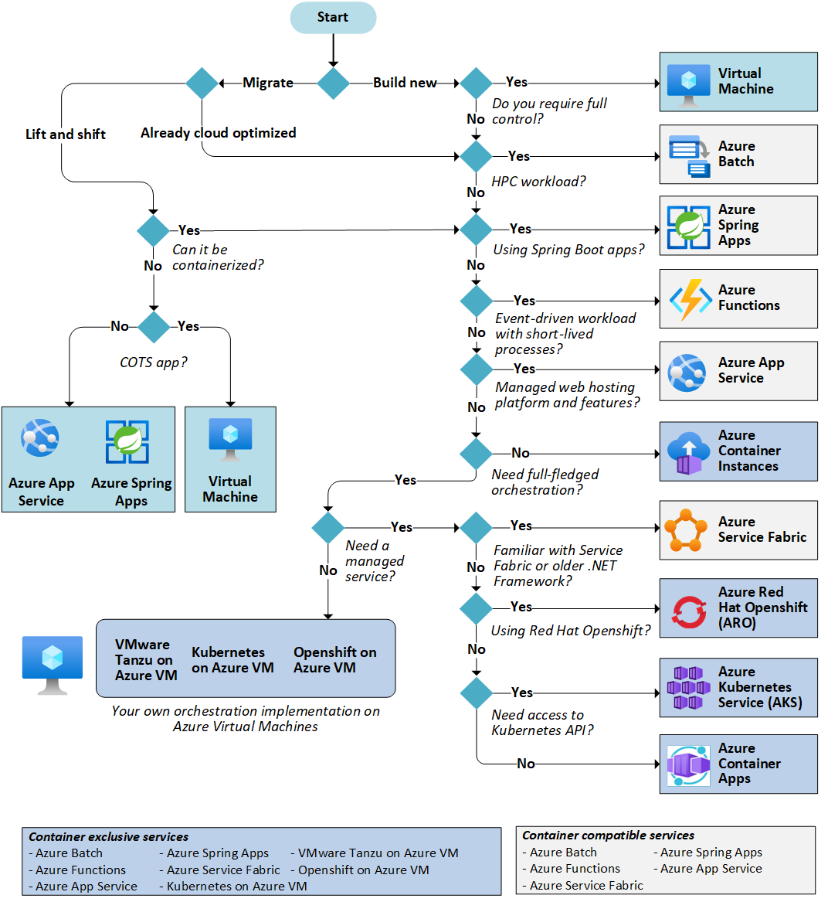

1. [Episode 10: Azure Networking Services | Virtual Network, Load Balancer, VPN Gateway, Application Gateway, CDN](https://marczak.io/az-900/#ep10)

## Azure Networking

* Connect cloud and on-premises.
* On-premise networking functionality.

### Azure Virtual Network

* **Logically isolated networking components**, an emulation of physically connected resources in the Cloud.
* Segmented into **one** or **more** **subnets**.
* Subnets are discrete sections.
* **Enable communication of resources** with each other, internet and on-premises.
* **Scoped to a single region**.
* ***VNet peering*** allows cross-region communication.
* Isolation, Segmentation, Communication, Filtering, Routing.
* A virtual network allows Azure resources to securely communicate with each **other**, the **internet**, and **on-premises networks**.
* A virtual network is scoped to a single region; however, multiple virtual networks from different regions can be connected together using virtual network peering.

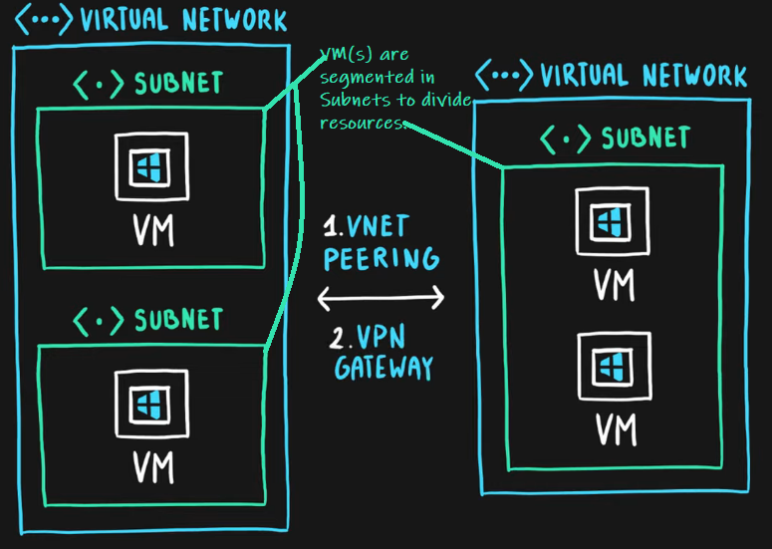

For communication between virtual machines, *Network Security Groups* (NSGs) are a critical piece to restrict unnecessary communication.

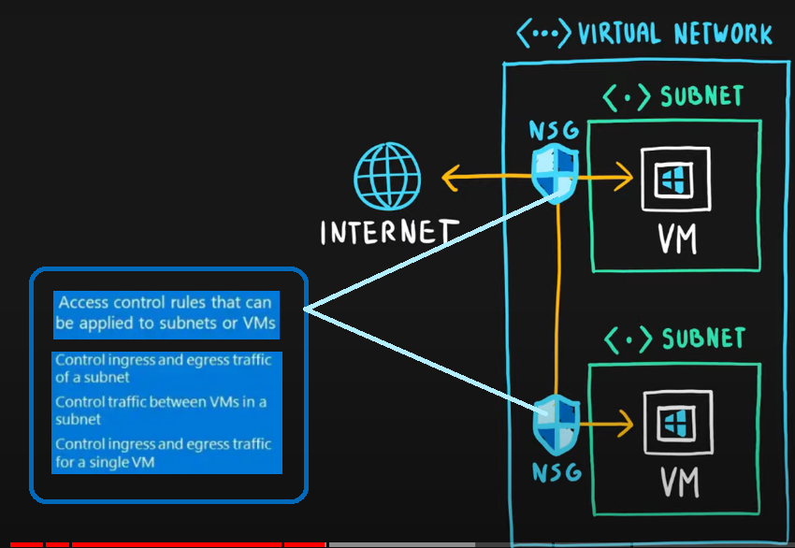

### Azure Load Balancer

* Even traffic distribution.

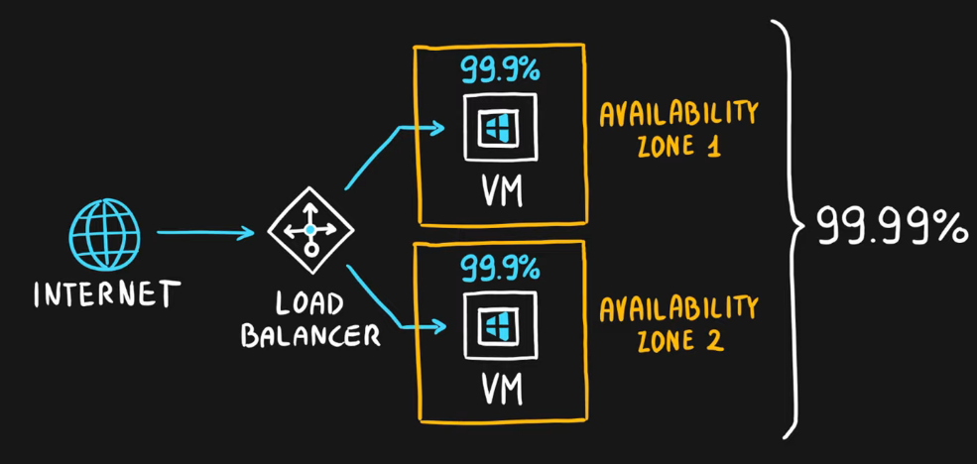

* Supports both inbound and outbound scenarios.
* ***High-availability*** scenarios.
* Both TCP (transmission control protocol) and UDP (user datagram protocol) applications.
* Internal and External traffic.
* Port Forwarding.
* High scale with up to millions of flows.
* A ***load balancer*** distributes traffic evenly among each system in a pool. A load balancer can help you achieve both high availability and resiliency.

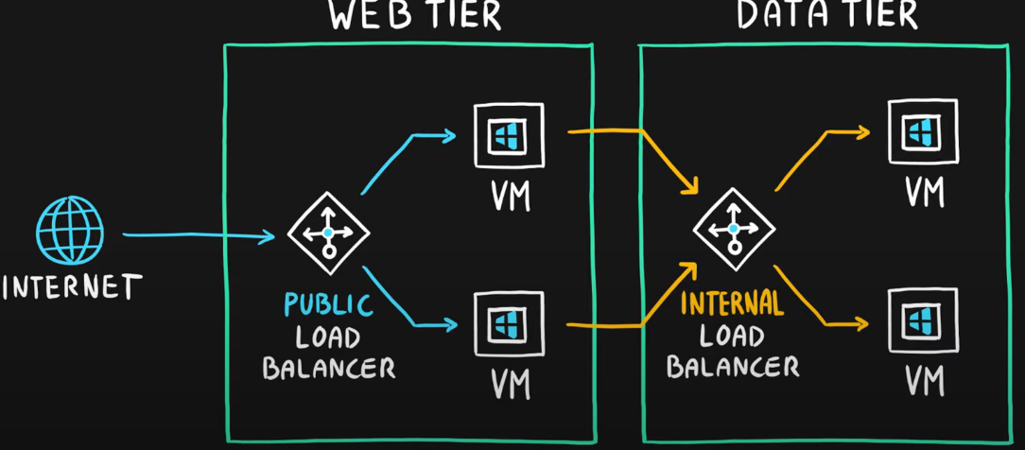

### VPN Gateway

* Specific type of virtual network gateway for on-premises to azure traffic over the public internet.
* ***VPN provides a secure connection between an Azure Virtual Network and an on- premises location over the internet.***

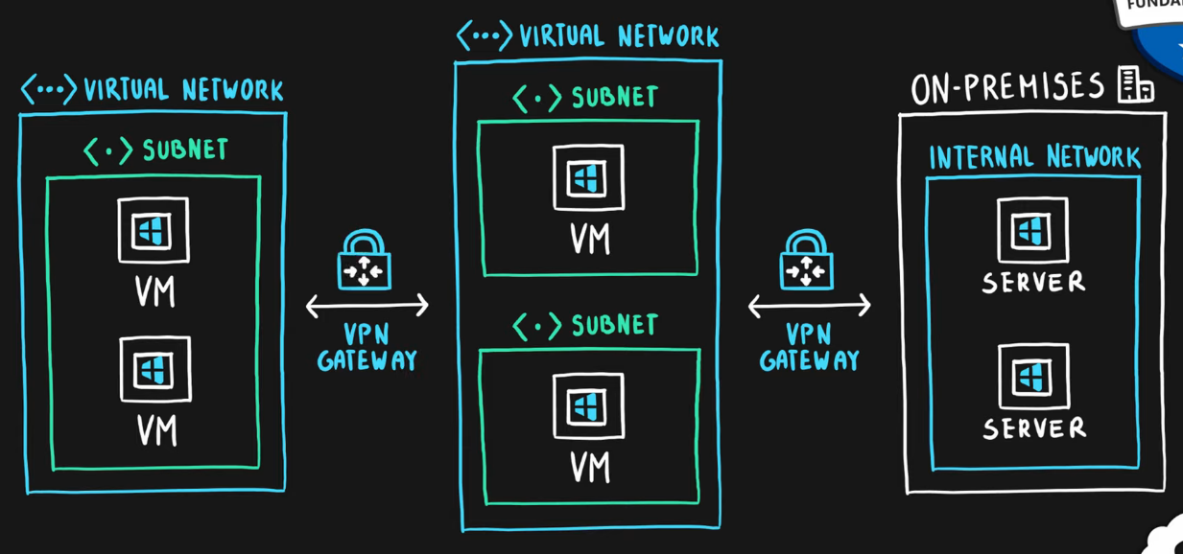

### Application Gateway

* **Web** traffic *load balancer*.
* ***If all your traffic is HTTP, a potentially better option is to use Azure Application Gateway. Application Gateway is a load balancer designed for web applications. It is designed to protect HTTP traffic.***
* Web application firewall.
* Redirection.
* Session affinity.
* URL Routing.
* SSL termination.

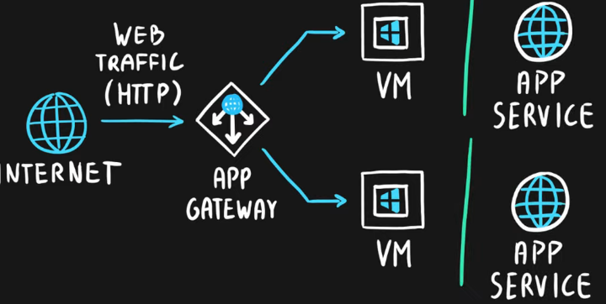

### Content Delivery Network

* Define content.
* Minimize latency.
* **POP (points of presence) with many locations.**
* A distributed network of servers that can efficiently deliver web content to users. ***It is a way to get content to users in their local region to minimize latency.***
* A content delivery network (CDN) is used to ***deploy a website in Azure that will be accessed by users worldwide and that hosts large video files for the best video playback experiences***

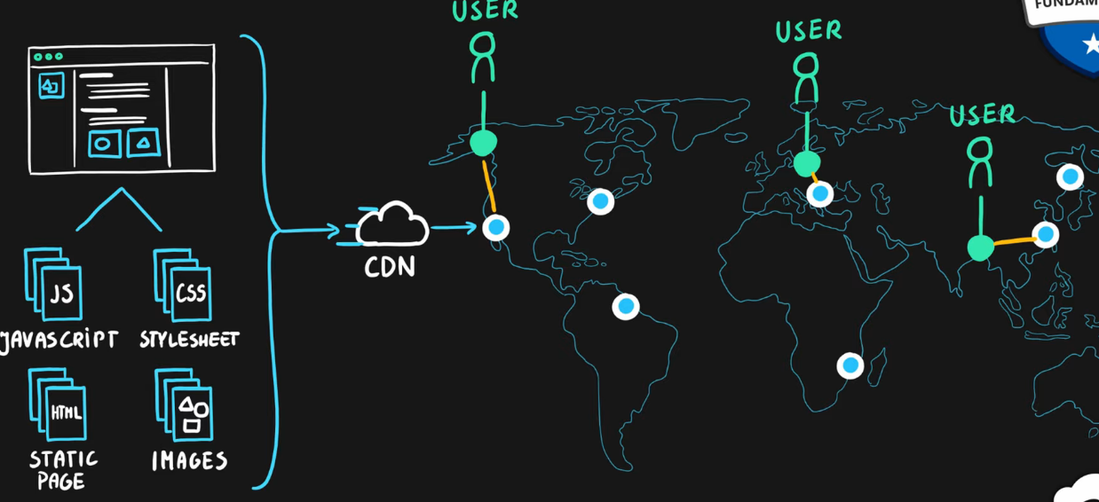

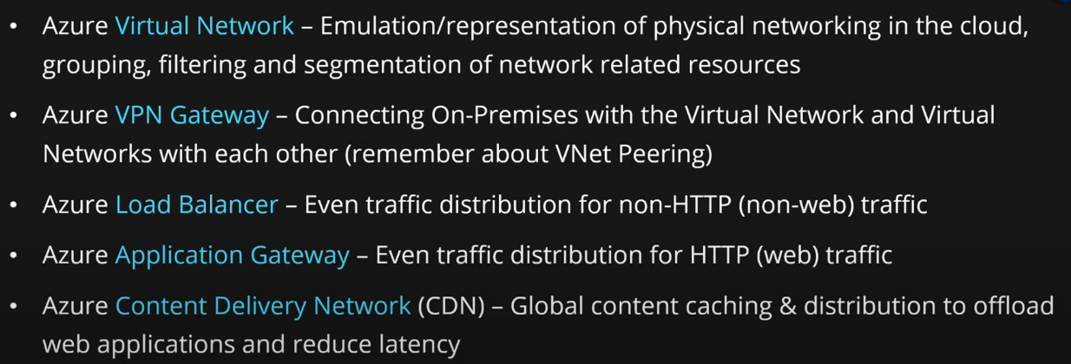

* ***A Local Network Gateway*** is an object in Azure that represents your on-premise VPN device.
* ***A Virtual Network Gateway*** is the VPN object in Azure at the end of the VPN.
* A ***'connection'*** is what connects the Local Network Gateway and the Virtual Network Gateway to bring up the VPN.  
  The local network gateway typically refers to your on-premises location. You give the site a name by which Azure can refer to it, then specify the IP address of the on-premises VPN device to which you will create a connection. You also specify the IP address prefixes that will be routed through the VPN gateway to the VPN device. The address prefixes you specify are the prefixes located on your on-premises network. If your on-premises network changes or you need to change the public IP address for the VPN device, you can easily update the values later.

1. [Episode 11: Azure Storage Services | Blob, Disk, File and Archive](https://marczak.io/az-900/#ep11)

## **Data Types**

* **Structured** - Data that can be **represented using tables** with very **strict schema**. Each row *must follow a defined schema*. Some tables have defined relationships between them. Typically used in relational databases.
* **Semi**-**structured** - Data that can be **represented using tables but without a strict defined schema**. Rows must only have a unique key identifier.
* **Unstructured** - Any files in **any format**. Like binary files, application files, images, movies, etc.

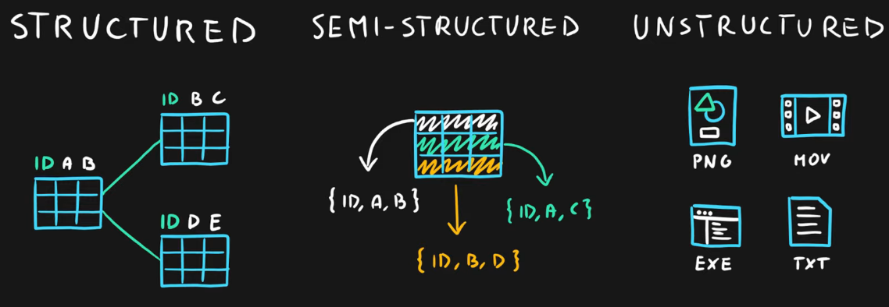

## **Storage Account**

* Group of services which include-
  + **blob storage,**
  + **queue storage,**
  + **table storage, and**
  + **file storage**
* Used to store-
  + **files**,
  + **messages**, and
  + **semi**-**structured** data
* Highly **scalable** (up to petabytes of data)
* Highly **durable** (99.999999999% - 11 nines, up to 16 nines)
* **Cheapest** per GB storage

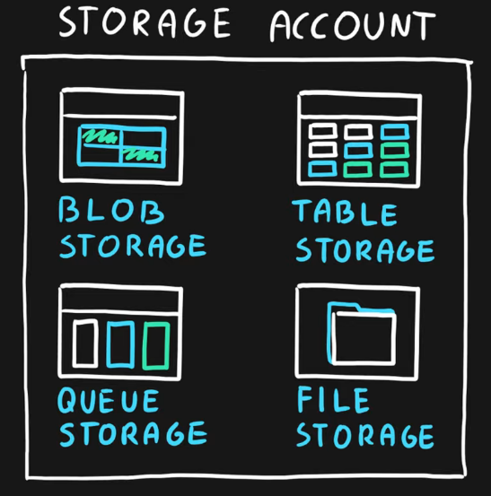

## **Blob Storage**

* BLOB – **binary large object** – **file**
* Designed for **storage of files of any kind**.
* Three storage tiers
  + **Hot** – **frequently accessed** data. E.g., WebApps
  + **Cool** – **infrequently accessed** data, stored for **at least 30 days**. (*lower availability*, *high durability*). E.g., Versions, Backups, etc.
  + **Archive** – rarely (if ever) accessed data. Stored for **at least 180 days**. E.g., Backups with the lowest prices.

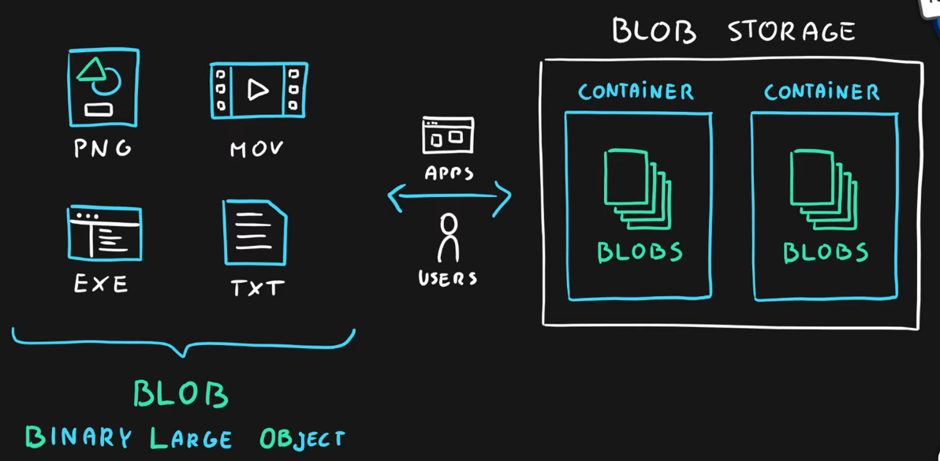

## **Queue Storage**

* Storage for small pieces of data (messages).
* Designed for scalable **asynchronous** processing.
* A data store for queuing and reliably delivering messages between applications

You can use queue storage to:

* Create a backlog of work and pass messages between different Azure web servers.
* Distribute load among different web servers/infrastructure and manage bursts of traffic.
* Build resilience against component failure when multiple users access your data at the same time.

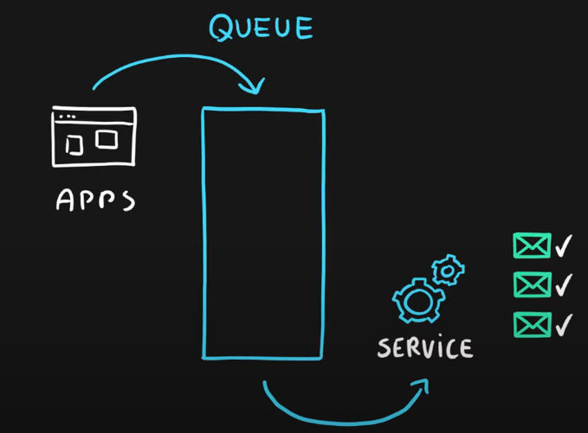

## **Table Storage**

* Storage for ***semi-structured data (NoSQL***)
  + No need for foreign **joins**, foreign **keys**, **relationships** or strict **schema**.
  + Designed for **fast access**.
  + Can store >= ***1 Table(s) / Storage***.
* Many programming interfaces and SDKs

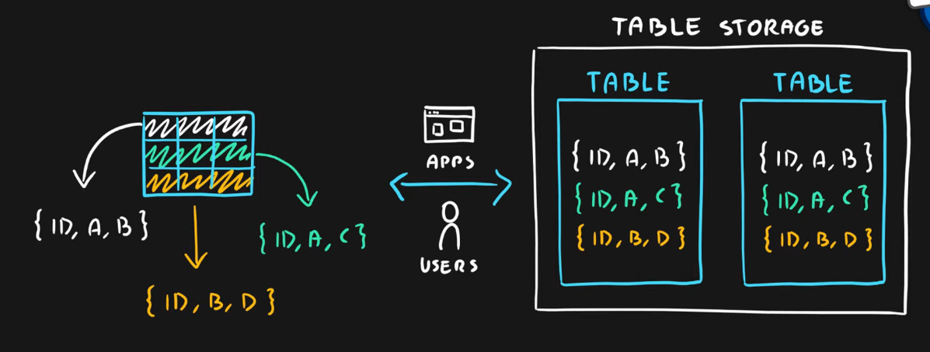

## **File Storage**

* Storage for files accessed via shared drive protocols.
* We can add ***persistent storage*** in AZURE FILE and DISK STORAGE Only!
* Designed ***to extend on-premise file shares*** or ***implement lift-and-shift scenarios***.

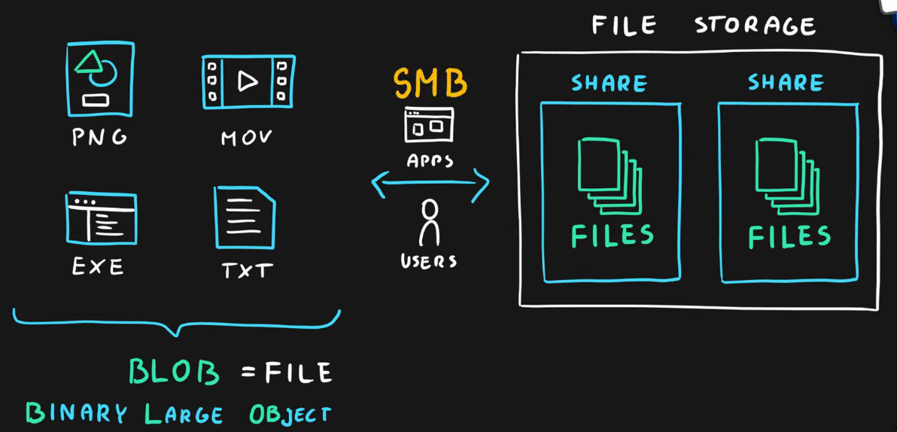

## **Disk Storage**

* Disk emulation in the cloud
* **Persistent storage** for Virtual Machines
* Different
  + ***sizes***,
  + ***types*** (SSD, HDD)
  + ***performance*** ***tiers***
* Disk can be **unmanaged** or **managed**.

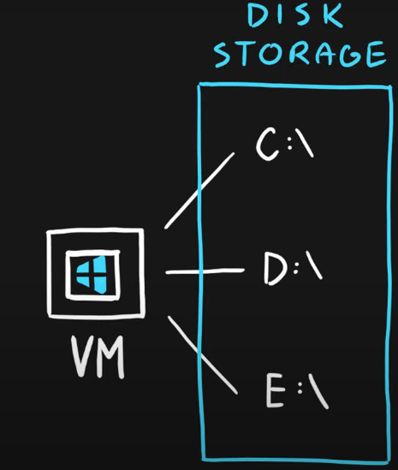 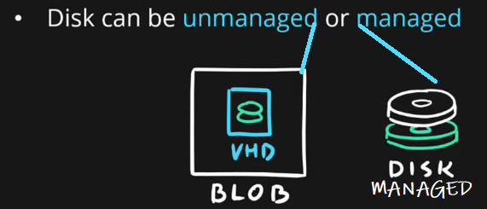

1. [Episode 12: Database Services | Cosmos DB, SQL Database, SQL DB for MySQL and PostgreSQL, SQL Managed Instance](https://marczak.io/az-900/#ep12)

## **Cosmos DB**

* **Globally** distributed **NoSQL** (semi-structured data) Database service
* Schema-less

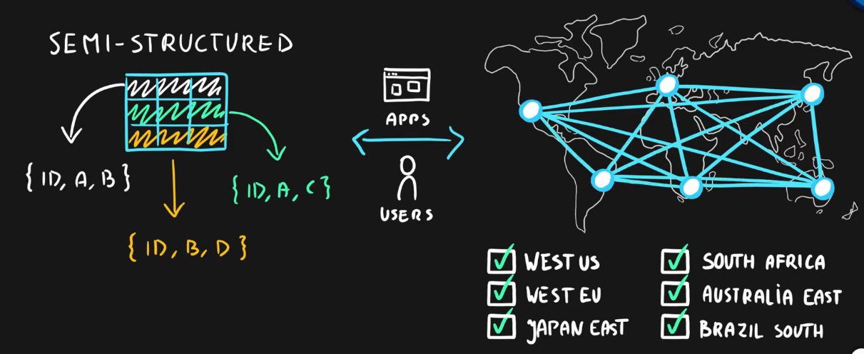

* Multiple APIs (SQL, MongoDB, Cassandra, Gremlin, Table Storage)
* You can use this feature to store data that is updated and maintained by users around the world
* Designed for
  + Highly responsive (real time) applications with super low latency responses <10ms
  + **Multi-regional** applications

## **SQL Database**

* **Relational database** service in the cloud (PaaS) (DBaaS - Database as a Service).
* **Structured data service** defined using schema and relationships.
* **Rich Query Capabilitie**s (SQL).
* **High-performance**, **reliable, fully managed**, and **secure** database for building – applications.

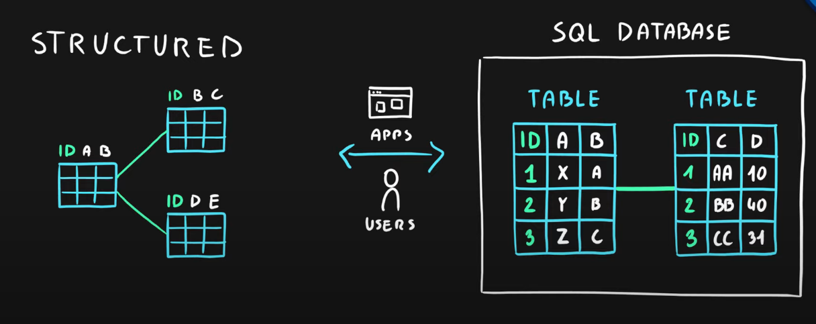

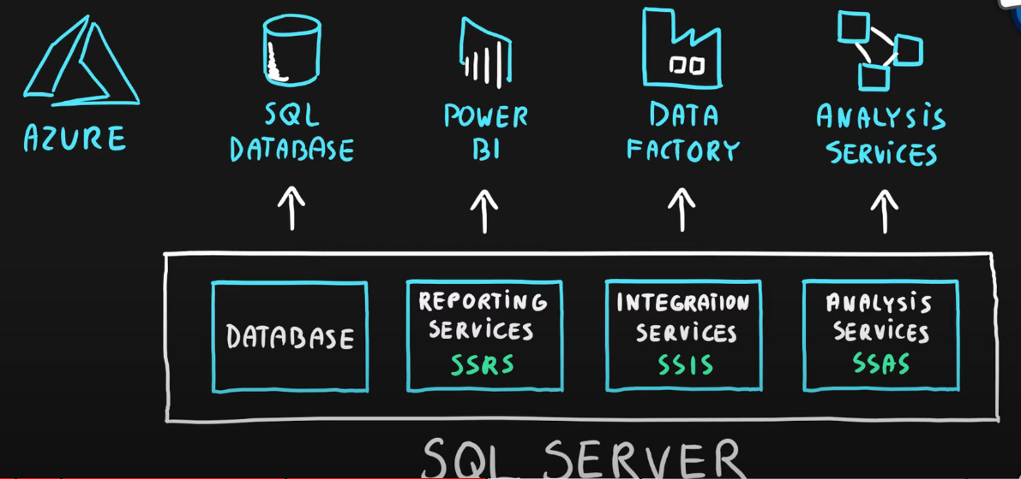

## **Azure SQL product family**

* Azure **SQL Database** – Reliable relational database based on SQL Server.
* Azure **Database for MySQL** – Azure SQL version for MySQL database engine.
* Azure **Database for PostgreSQL** – Azure SQL version for PostgreSQL database engine.
* Azure **SQL Managed Instance** – Fully fledged SQL Server managed by the cloud provider.
* Azure **SQL on VM** – Fully fledged SQL Server on *IaaS*.
* Azure **SQL DW (Synapse)** – Massively ***Parallel Processing*** (MPP) version of SQL Server.

|  |  |
| --- | --- |
| DATA | AZURE SERVICE |
| STRUCTURED | **SQL** DB, **SQL** Managed Instance, DB for **MySQL**, DB for **PostgreSQL**, **SQL** Data Warehouse, **SQL** on VM |
| SEMI-STRUCTURED | **Table Storage**, **Cosmos DB-** Multiple APIs (SQL, MongoDB, Cassandra, Gremlin, Table Storage) |
| UNSTRUCTURED | **BLOB** Storage, **File** Storage |

1. [Episode 13: Azure Marketplace](https://marczak.io/az-900/#ep13)

## **Azure Marketplace**

* Think of it like an “Azure Shop” where you purchase services and solutions for the Azure platform.

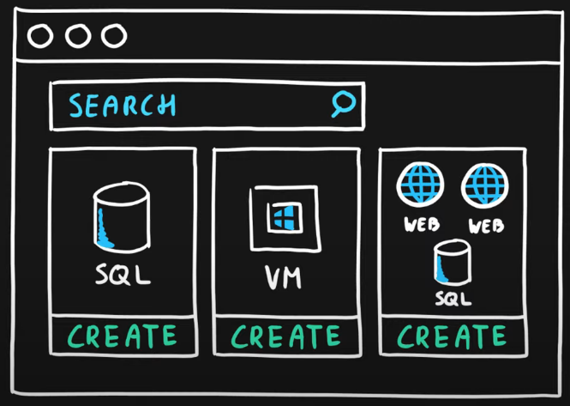

* Each product is a template that contains one or multiple services.
* Products are delivered by first and third-party vendors.
* Solutions can leverage all service categories like IaaS, PaaS and SaaS.

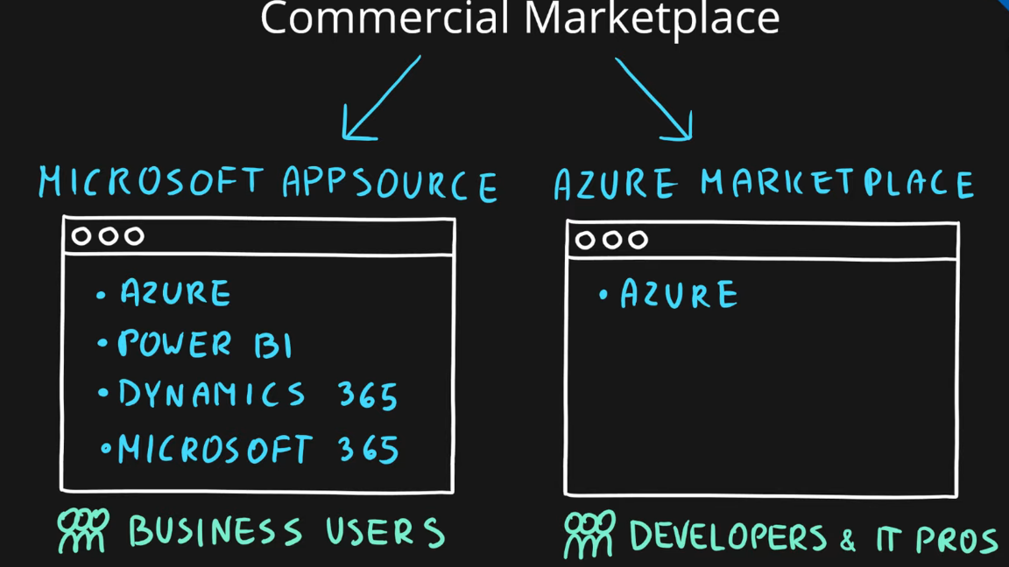

1. [Episode 14: Azure IoT Services | IoT Hub, IoT Central, Azure Sphere](https://marczak.io/az-900/#ep14)

## **What is the Internet of Things?**

The Internet of Things (**IoT**) is a network of internet-connected devices (**IoT Devices**) embedded in everyday objects enabling sending and receiving data such as **settings** and **telemetry**.

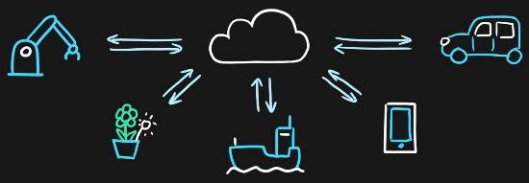

## **Azure IoT Hub**

* Managed service for **bi-directional communication**
* Platform as a Service (PaaS)
* Highly secure, scalable, and reliable
* Integrates with a lot of Azure Services
* **Programmable SDKs** for popular languages (C, C#, Java, Python, Node.js)
* Multiple protocols (HTTPS, AMQP, MQTT)

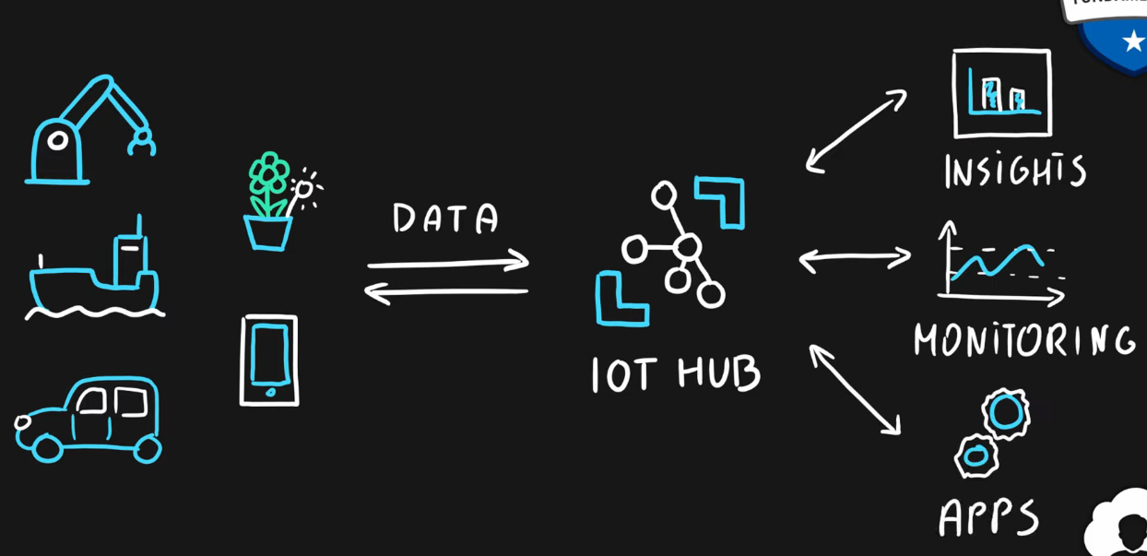

## **Azure IoT Central**

* IoT App Platform - Software as a Service (SaaS)
* Industry-specific app templates
* No deep technical knowledge is required.
* Service for connecting, managing, and monitoring IoT devices.
* Highly secure, scalable, and reliable.
* Built on top of the IoT Hub service and 30+ other services.

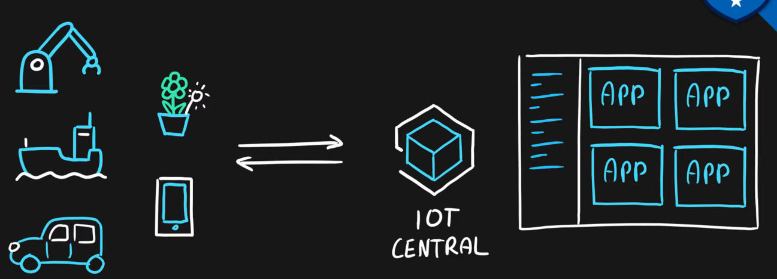

## **Azure Sphere**

* Secure end-2-end IoT Solutions
  + Azure Sphere certified chips (microcontroller units - MCUs)
  + Azure Sphere OS based on Linux.
  + Azure Security Service trusted device-to-cloud communication.

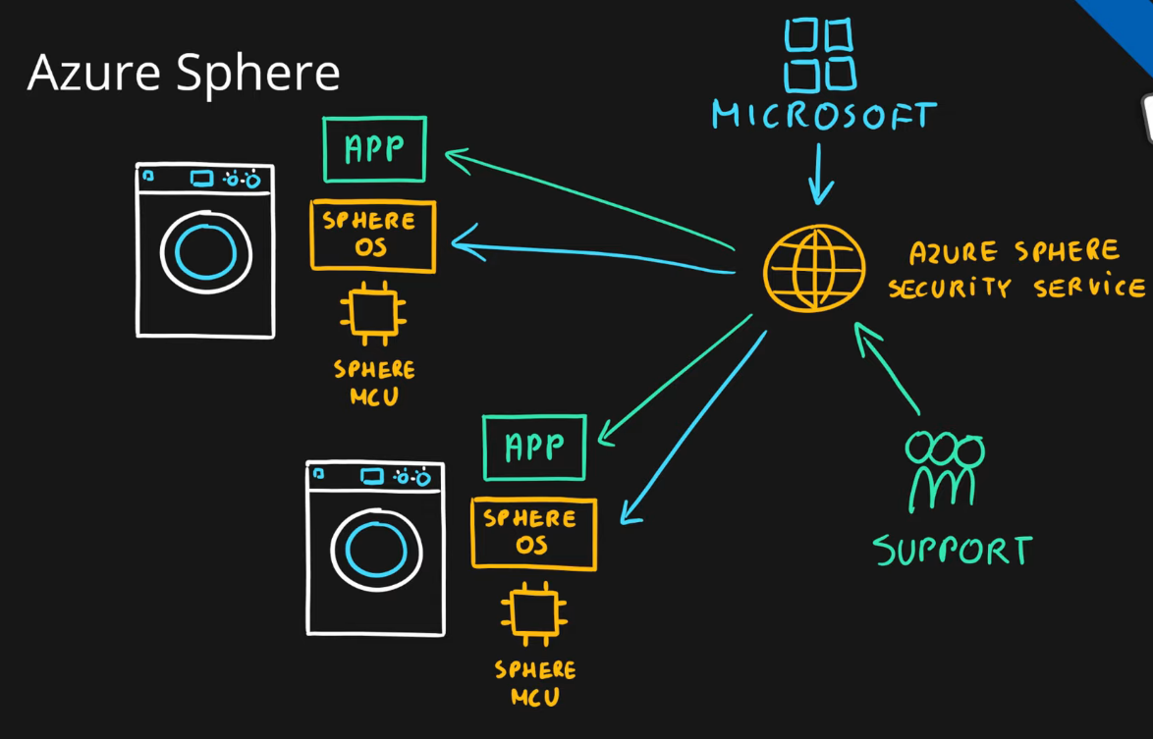

1. [Episode 15: Azure Big Data and Analytics Services | Synapse Analytics (SQL Datawarehouse), HDInsight, Databricks](https://marczak.io/az-900/#ep15)

## **What is Big Data?**

**Big Data** is a field of technology that helps with the **extraction**, **processing** , and **analysis** of information that is **too large or complex** to be dealt with by traditional software.

### The three V’s rule

Big data typically has one of the following characteristics-

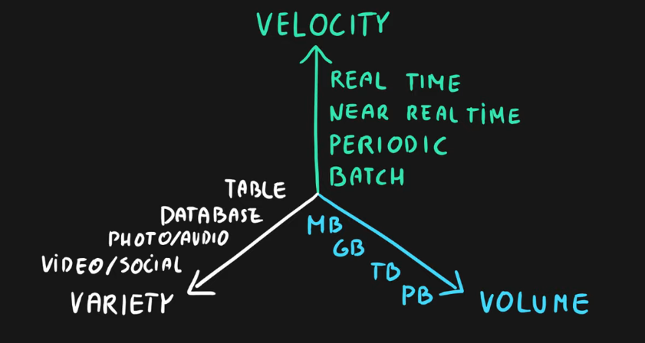

## **Azure Synapse Analytics**

* Big data analytics platform (PaaS)
* Multiple components
  + **Spark**
  + **Synapse** **SQL**
    - **SQL** pools (dedicated – pay for provisioned performance)
    - **SQL** on-demand (ad-hoc – pay for TB processed)
  + Synapse Pipelines (Data Factory – ETL)
  + Studio (unified experience)
  + ***Leverages massive parallel processing (MPP)*** to run complex queries quickly across petabytes of data.

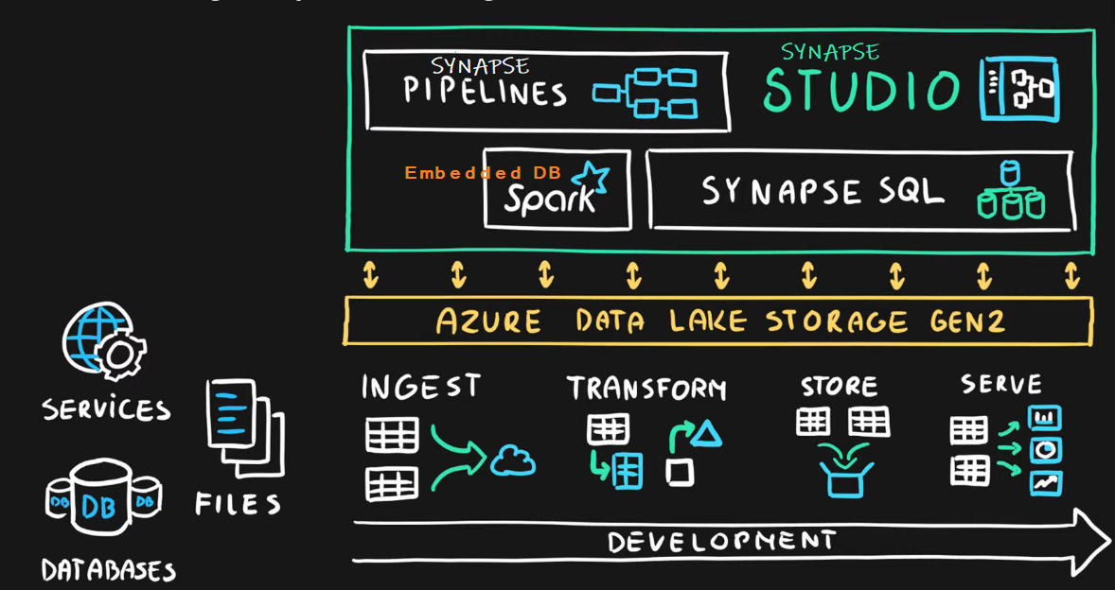

## **Azure HDInsight**

* Flexible multi-purpose big data platform (PaaS)
* Multiple technologies supported (Hadoop, Spark, Kafka, HBase, Hive, Storm, Machine Learning)
* Process massive amounts of data with **managed clusters of Hadoop** clusters in the cloud

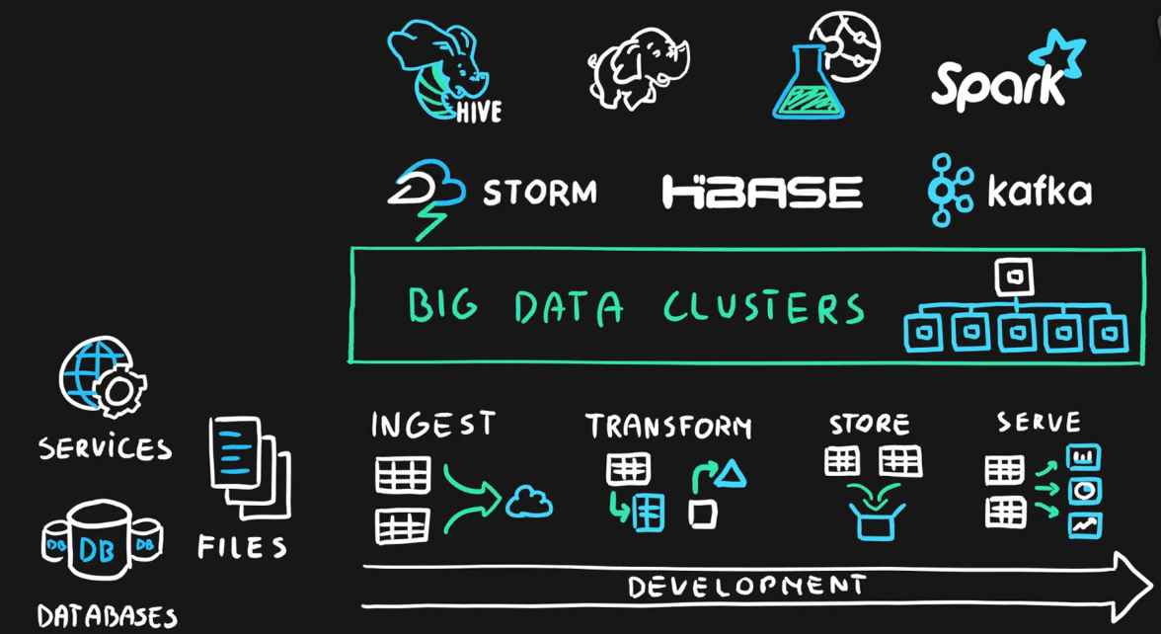

## **Azure Databricks**

* Big data collaboration platform (PaaS)
* Unified workspace for notebook, cluster, data, access management, and collaboration
* ***Based on Apache Spark***
* Integrates very well with common Azure data services.

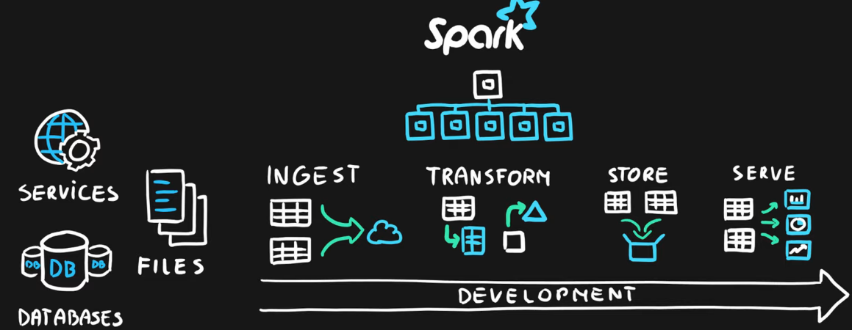

1. [Episode 16: Azure Artificial Intelligence (AI) Services | Machine Learning Studio and Service](https://marczak.io/az-900/#ep16)

### What is Artificial Intelligence?

**Artificial Intelligence** (**AI**) is the simulation of human intelligence & capabilities by computer software.

### What is Machine Learning?

**Machine Learning** is a subcategory of AI where computer software is “**taught**” to **draw conclusions** and **make predictions** **from data**.

## **Azure Machine Learning**

* Cloud-based platform for creating, managing, and publishing machine learning models
* Platform as a Service (PaaS)

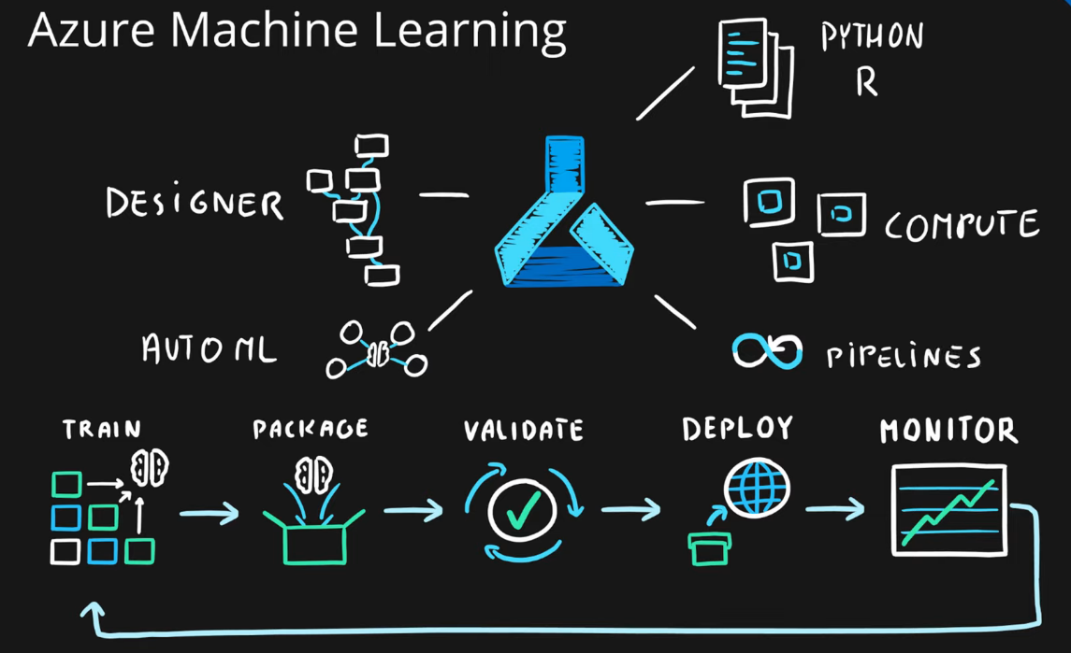

* Machine Learning Workspace – top-level resource
* Machine Learning Studio – web portal for end-2-end development
* Features-
  + Notebooks – using Python and R.
  + Automated ML – **run multiple algorithms/parameter combinations, and choose the best model.**
  + Designer – **graphical interface** for no-code development.
  + Data & Compute – **management** of **storage** and **compute** resources.
  + Pipelines – orchestrate **model training, deployment,** and **management** **tasks**.

1. [Episode 17: Azure Serverless Computing Services | Functions, Logic Apps, Event Grid](https://marczak.io/az-900/#ep17)

### What is Serverless?

**Serverless computing** is a cloud-hosted execution environment that allows customers to **run their applications** in the cloud while **completely abstracting underlying infrastructure**.

## **Azure Functions**

* Serverless coding platform (Functions as a Service, FaaS)
* Designed for **nano-service architectures** and **event-based applications**
* **Scales up and down very quickly**.
* Highly scalable
* Supports popular **languages** and frameworks (.NET & .NET Core, Java, Node.js, Python, PowerShell, etc.)

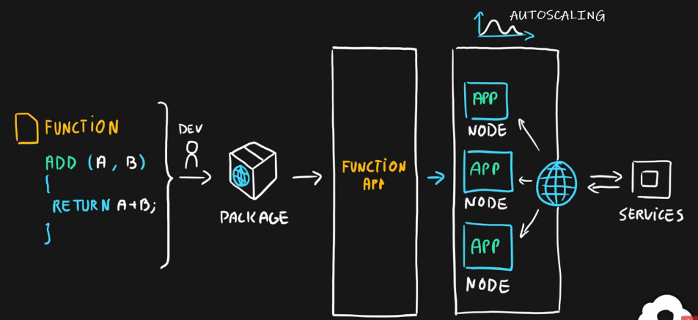

## **Azure Logic Apps**

* Serverless enterprise integration service (PaaS)
* 200+ connectors for popular services
* Designed for the orchestration of
  + business processes,
  + integration workflows for applications, data, systems, and services
* No-code solution.

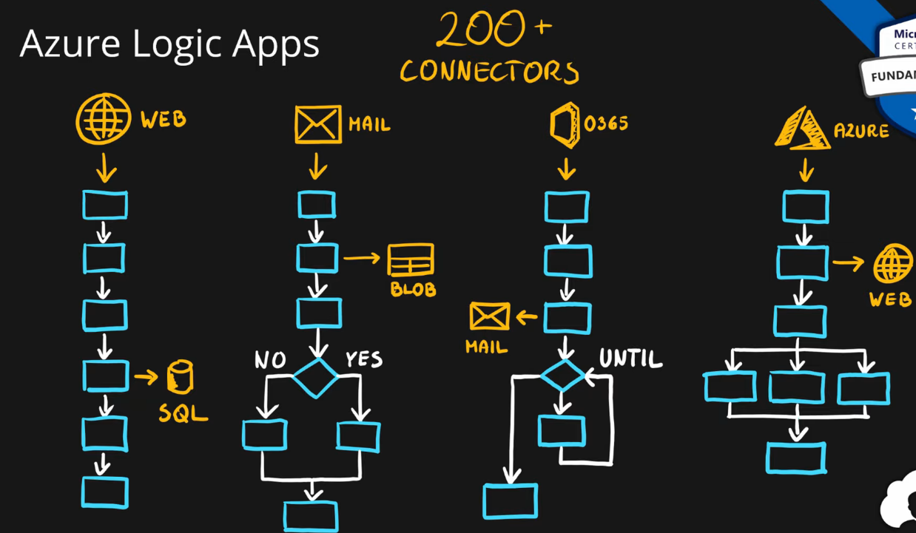

## **Azure Event Grid**

* Fully managed serverless event routing service
* Uses publish-subscribe model
* Designed for event-based and near-real time applications
* Supports dozen of built-in events from most common Azure services

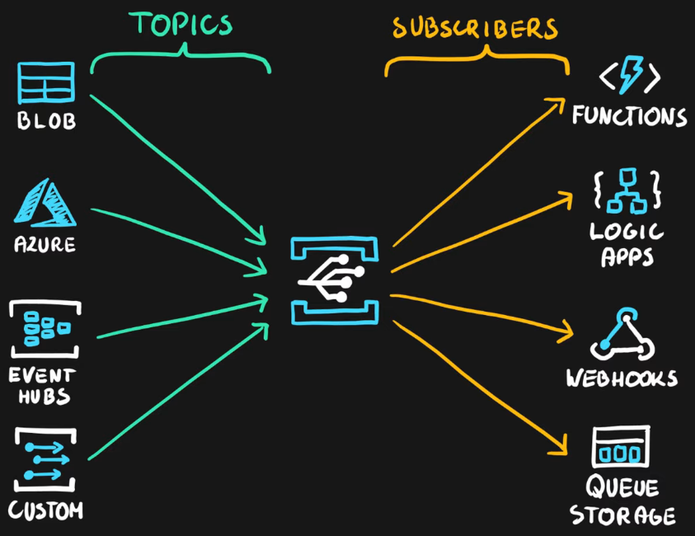

1. [Episode 18: Azure DevOps Solutions | Azure DevOps, DevTest Labs](https://marczak.io/az-900/#ep18)

## **What is DevOps?**

**DevOps** is a set of practices that combine both development (**Dev**) and operations (**Ops**).

DevOps aims to **shorten the development life cycle** by providing **continuous integration** and **delivery** (**CI/CD**) capabilities while **ensuring high quality** deliverables.

## **Azure DevOps**

* **Collection of services** for building solutions using DevOps practices
* Services included
  + **Boards** – tracking work
  + **Pipelines** – building CI/CD workflows (build, test and deploy apps)
  + **Repos** – code collaboration and versioning with Git
  + **Test Plans** – manual and exploratory testing
  + **Artifacts** – manage project deliverables
* Extensible with **Marketplace** – over 1000 of available apps
* Evolved from **TFS** (Team Foundation Server), through **VSTS** (Visual Studio Team Services.

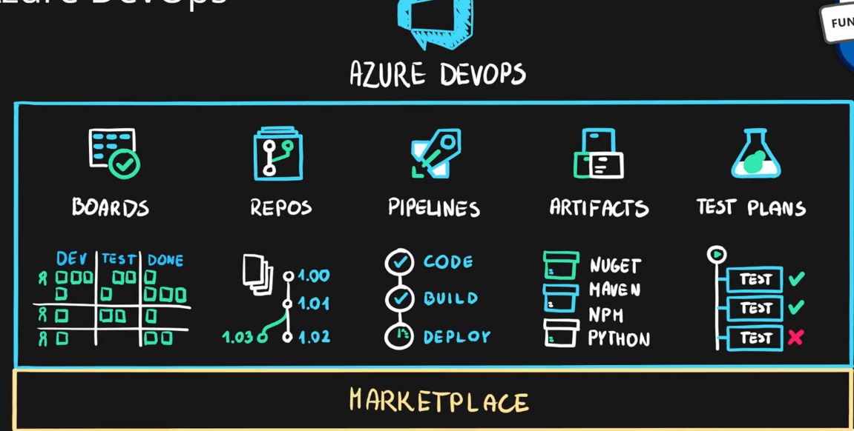

## **Azure DevTest Labs**

* Service for creation of **sandbox environments** for developers/testers (PaaS)
* Quickly create on-demand Windows and Linux environments you can use to test or demo your applications directly from your deployment pipelines
* Quick setup of **self-managed virtual machines**
* **Preconfigured templates** for VMs
* Plenty of additional **artifacts** (tools, apps, custom actions)
* Lab **policies** (quotas, sizes, auto-shutdowns)
* **Share** and **automate** labs via custom images
* Premade plugins/API/tools for **CI/CD pipeline automation**

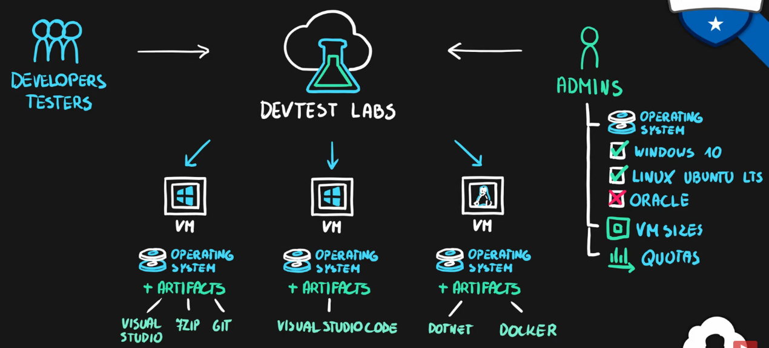

1. [Episode 19: Azure Tools | Portal, PowerShell, CLI and Cloud Shell](https://marczak.io/az-900/#ep19)

## **Azure Portal**

* Public web-based interface for management of the Azure platform
* Designed for self-service
* Customizable
* Simple tasks

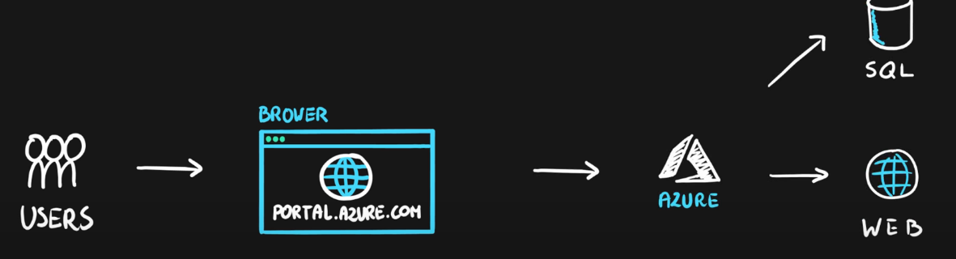

## **Azure PowerShell**

* PowerShell and module
* Designed for automation
* Multi-platform with PowerShell Core
* Simple to use
  + Connect-AzAccount – log into Azure
  + Get-AzResourceGroup – list resource groups
  + New-AzResourceGroup – create new resource group
  + New-AzVm – create virtual machine

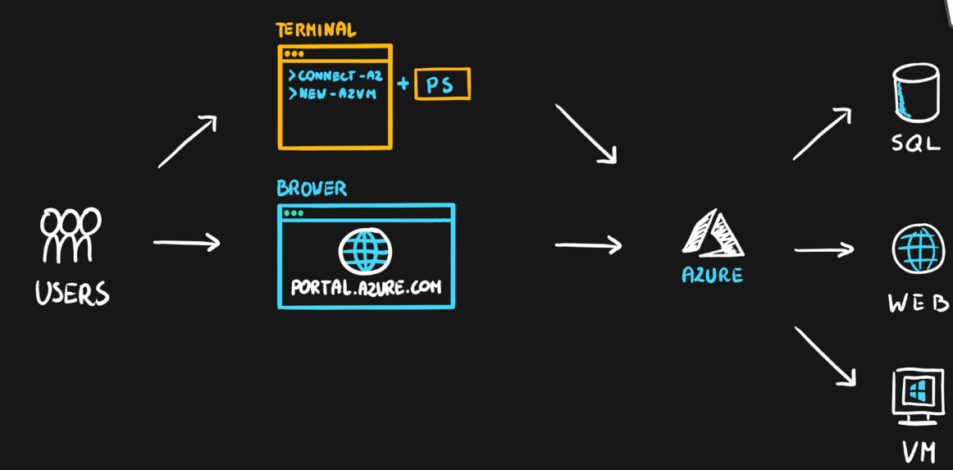

## **Azure CLI**

* Command Line Interface for Azure
* Designed for automation
* Multi-platform (Python)
* Simple to use
  + az login – log into Azure
  + az group list – list resource groups
  + az group create – create new resource group
  + az vm create – create virtual machine
* Native OS terminal scripting

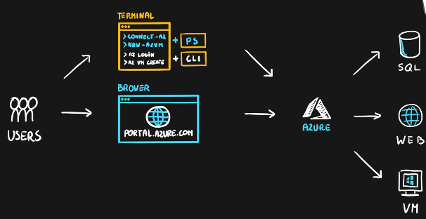

## **Azure Cloud Shell**

* Cloud-based scripting environment
* Completely free
* Supports both Azure PowerShell and Azure CLI
* Dozen of additional tools
* Multiple client interfaces
  + Azure Portal integration (portal.azure.com)
  + Shell Portal (shell.azure.com)
  + Visual Studio Code Extension
  + Windows Terminal
  + Azure Mobile App
  + Microsoft Docs integration

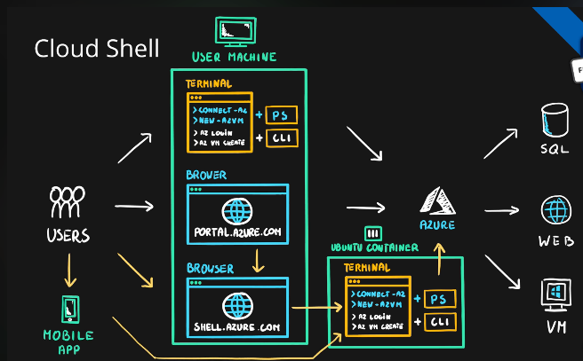

1. [Episode 20: Azure Advisor](https://marczak.io/az-900/#ep20)

## **Azure Advisor**

* **Personalized consultant** service
* Designed to provide **recommendations** and **best practices** for
  + **Cost** (SKU sizes, idle services, reserved instances, etc.)
  + **Security** (MFA settings, vulnerability settings, agent installations, etc.)
  + **Reliability** (redundancy settings, soft delete on blobs, etc.)
  + **Performance** (SKU sizes, SDK versions, IO throttling, etc.)
  + **Operational** Excellence (service health, subscription limits, etc.)
* **Actionable** recommendations
* **Free**!

